Skyline Small Molecule Quantification

The Skyline Targeted Mass Spectrometry Environment provides informative visual displays of the raw mass spectrometer data you import into your Skyline documents. Originally developed for proteomics use, Skyline has been extended to work with generalized molecules. This tutorial explores a relatively straightforward example of using Skyline for targeted quantification of a single small molecule using an external calibration curve and stable-isotope labeled internal standard.

In this tutorial, you will learn about Targeted Quantification based on TQ-MS (in this example, out of crashed plasma) starting from a method you may already be running (e.g. a pharmacokinetic assay). In the analysis of this dataset you will learn:

* Insertion of simple set of known transitions
* Data Analysis and peak integration for non-proteomic molecules
* Small Molecule Quantification workflow in Skyline

You may also wish to view the second half of [Skyline Tutorial Webinar 16](https://skyline.ms/webinar16.url), on which this tutorial is based.

Skyline aims to provide a vendor-neutral platform for targeted quantitative mass spectrometry research. It can import raw data from the instrument vendors Agilent, SCIEX, Bruker, Shimadzu, Thermo-Scientific, and Waters. The ability to import data across various instrument platforms facilitates cross-instrument comparisons and multi-site studies. This remains equally true in using it to target small molecules, as it has been for years in the field of proteomics.

If you have not already looked at the “[Skyline Small Molecule Targets](https://skyline.ms/tutorial_small_molecule.url)” tutorial you should do so now, in order to pick up a few basics about how Skyline works with small molecule descriptions including chemical formulas and adducts.

# Getting Started

To start this tutorial, download the following ZIP file:

<https://skyline.ms/tutorials/SmallMoleculeQuantification.zip>

Extract the files in it to a folder on your computer, like:

C:\Users\bspratt\Documents

This will create a new folder:

C:\Users\bspratt\Documents\SmallMoleculeQuant

It will contain all the files necessary for this tutorial.

If you have been using Skyline prior to starting this tutorial, it is a good idea to revert Skyline to its default settings. To do so:

* Start Skyline.
* On the **Start Page,** click **Blank Document** which looks like this:

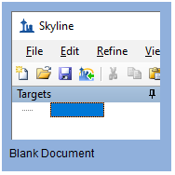

* On the **Settings** menu, click **Default.**
* Click **No** on the form asking if you want to save the current settings.

The document settings in this instance of Skyline have now been reset to the default.

Since this tutorial covers a small molecule topic, you can choose the molecule interface by doing the following:

* Click the user interface control in the upper right-hand corner of the Skyline window, and click **Molecule interface** which looks like this:

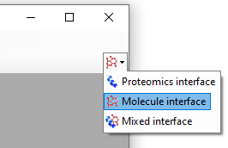

Skyline is operating in molecule mode which is displayed by the molecule icon  in the upper right-hand corner of the Skyline window. Its original proteomics menus and controls are now hidden, allowing you to focus on small molecule analysis.

# Experimental Layout

This experiment was designed according to the FDA Guidance on Bioanalytical Method Validation, and as such contains much more than just the study samples. A full description of the plate layout and run order typically utilized for such a study has been published (<https://www.ncbi.nlm.nih.gov/pubmed/29039849>). Briefly, the samples for this dataset were laid out in a 96 well plate as follows:

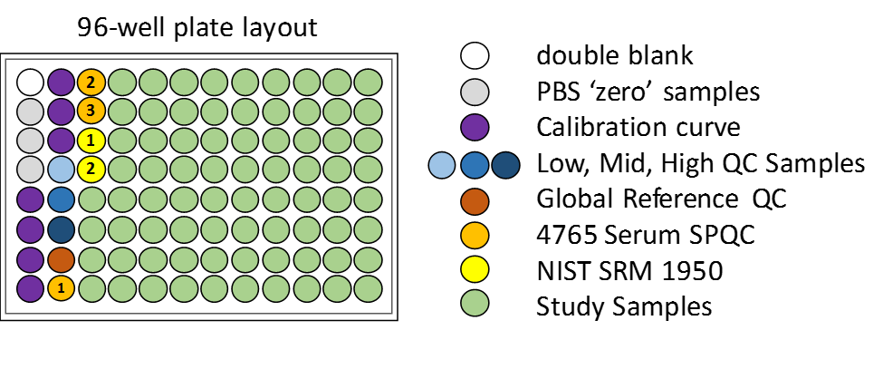

Blanks, or “zero” standards, contain only the internal standard, double blanks contain no standard at all.

Calibration curve samples are a dilution series for calibration.

QC samples are “known unknowns”. These are quality control samples which are treated as unknowns in this study. In actuality, it is known what the results should be and thus they can be used to check the accuracy of measurements.

Serum SPQC is a serum pooled QC, a pooling of all study samples which is run at several points at the start, middle and end of the experiment to verify that quantitative reproducibility is constant across the study.

The NIST SRM 1950 is a pooled plasma standard from the National Institute for Standards and Technology, which is available to all researchers as a reference standard for “normal” plasma metabolite measurements. It serves as a reference between studies in different laboratories.

Injections were performed in this order:



In all, 113 injections were used in collecting the mass spec data for these samples.

# Internal Standards

For this study there are just two targets: a molecule and an internal standard, which is an isotopically labeled variant of the molecule and thus co-elutes. It is also possible to establish a relationship between unrelated molecules by declaring one of the molecules as a surrogate standard. The surrogate standard method is covered in the “[Skyline High Resolution Metabolomics](https://skyline.ms/tutorial_hi_res_metabolomics.url)” tutorial.

# Importing a Small Molecule Transition List into a Skyline Document

The easiest way to get a small molecule transition list into a Skyline document is to start with an empty document and use the **Edit > Insert > Transition List** menu item.

To begin, do the following:

* On the Skyline **Edit** menu, choose **Insert** and click **Transition List**.

Skyline will show the **Insert Transition List** form:

Normally, you would copy and paste a transition list from Excel or some other external source, but in this case, the transition list is small enough that we can just show it here:

* Select the two rows below by dragging over them and then **Copy** (Ctrl-C).

DrugX,Drug,light,283.04,1,129.96,1,26,16,2.7  
DrugX,Drug,heavy,286.04,1,133.00,1,26,16,2.7

* In Skyline, click on the blank area of the **Insert Transition List** form.
* Press **Ctrl-V** to paste.

Skyline shows the **Import Transition List: Idenfity Columns** form, where you can tell Skyline what each column means.

* Make sure that the **Molecules** radio button is selected.

The data we copied did not have column headers, so initially each column is set as “Ignore Column”.

* Use the **drop-down control in each column** to set the column type.
* The column order from left to right is: Molecule List Name, Molecule Name, Label Type, Precursor m/z, Precursor Charge, Product m/z, Product Charge, Cone Voltage, Explicit Collision Energy, Explicit Retention Time.

The **Import Transition List: Identify Columns** form should now look like this:

* Click the **OK** button.

|  |
| --- |
| NOTE: In this tutorial, you have provided only *m/z* and charge values for these targets. Skyline can accept higher level descriptions including chemical formulas and heavy isotope labels etc. Having the chemical formula is especially useful when working with full scan, high resolution data as it allows Skyline to calculate isotopic distributions, but for SRM data such as this, using *m/z* and charge is adequate. |

To see the newly imported targets in full detail:

* On the **Edit** menu, choose **Expand All** and click **Precursors**.

Your Skyline window should now look like this:

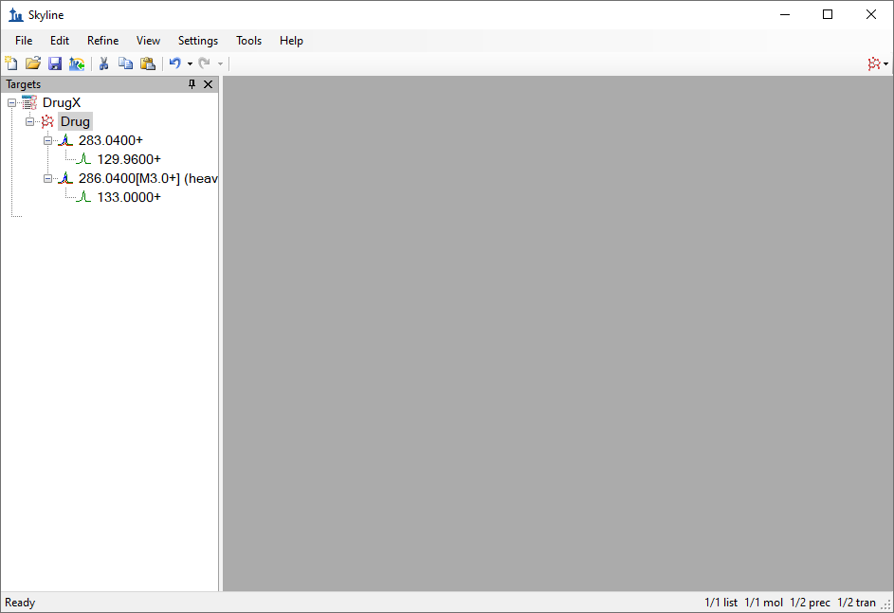

# Transition Settings

The next step is to make sure the transition settings are correct for importing the experimental mass spectrometer results. To do this, perform the following steps:

* On the **Settings** menu, click **Transition Settings**.
* On the **Prediction** tab, in the **Collision energy** dropdown list, choose “Waters Xevo”.
* Check **Use optimization values when present**.
* In the **Optimize by** dropdown list which appears when you do this, choose **Transitions**.

The **Transition Settings** form should now look like this:

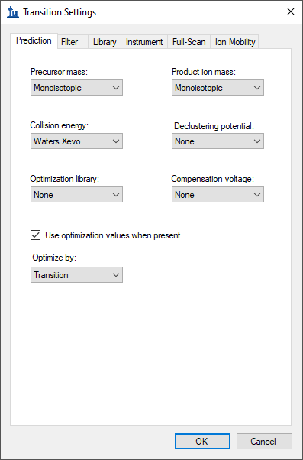

* Click the **Filter** tab.
* In the **Precursor adduct** field, change the text to “[M+H]”.
* In the **Fragment adduct** field, change the text to “[M+]”.

The **Transition Settings** form should now look like this:

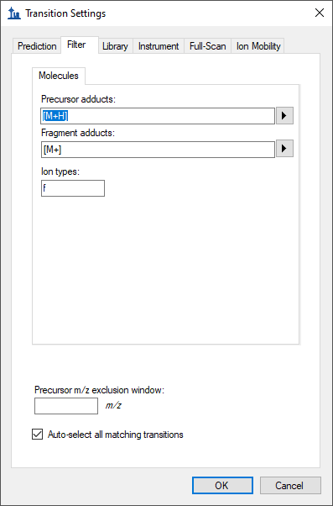

In the **Ion types** field, the value “f” indicates only fragment ion transitions will be measured. If you wanted to measure precursor ions as well, you would use “f, p”.

In the **Instrument** tab, the default values will work for this experiment. In your own work, however, make sure that the minimum and maximum *m/z* values make sense for your actual instrument. The purpose of these settings is to keep you from adding target transitions that your mass spectrometer is not actually able to measure.

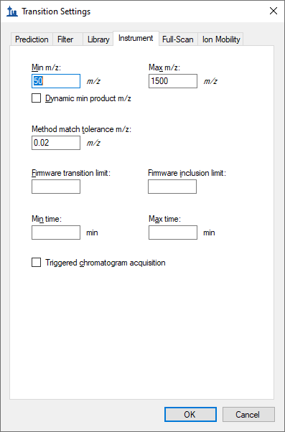

The **Method match tolerance** is another important setting in the **Instrument** tab. It determines how closely the *m/z* values from an instrument method – which get stored in the raw data files – must match the *m/z* values in the Skyline **Targets** list. The default value in Skyline is 0.055 because original SRM files used in testing were specified to one decimal place (e.g. 784.3) but included some slight rounding errors. If you export your methods from Skyline, you likely could use a much smaller tolerance.

* Click the **OK** button.

The next step is to import the experimental mass spectrometer results.

# Importing Mass Spectrometer Runs

This experiment has 113 mass spectrometer data files associated with it. In cases like this, it can be useful to initially import just a handful of the unknowns along with all of the calibration curve runs and quality control (QC) runs. Though, you may also wish to start out with an even less complicated document to verify data quality, importing only a few runs to start, perhaps the calibration curve runs with the highest concentrations.

Here you will take the more ambitious approach by performing the following steps:

* On the **File** menu, click **Save**. (Ctrl-S)
* Save this document as “SMQuant_v1.sky” in the folder created for this tutorial.
* On the **File** menu, select **Import** and click **Results**.
* In the **Import Results** form, choose **Add single-injection replicates in files**. In the **Files to import simultaneously** dropdown list at the bottom of the form, choose **Many** which will provide the best import performance.

The **Import Results** form should now look like this:

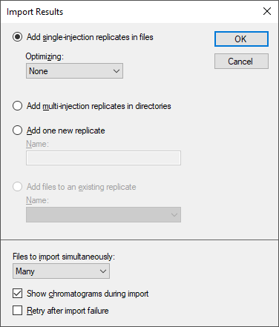

* Click the **OK** button.
* In the **Import Results Files** form that appears, select the last 16 unknown samples and all the QC samples by clicking the “80_0_1_1_00_1021523383.raw” file and then holding down the shift key and clicking the last file in the list.

The **Import Results Files** form should look like:

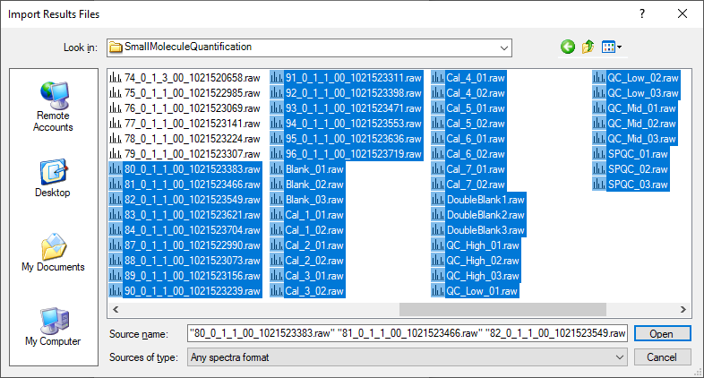

* Click the **Open** button.

The files should import within 30 seconds or so, leaving your Skyline window looking like this:

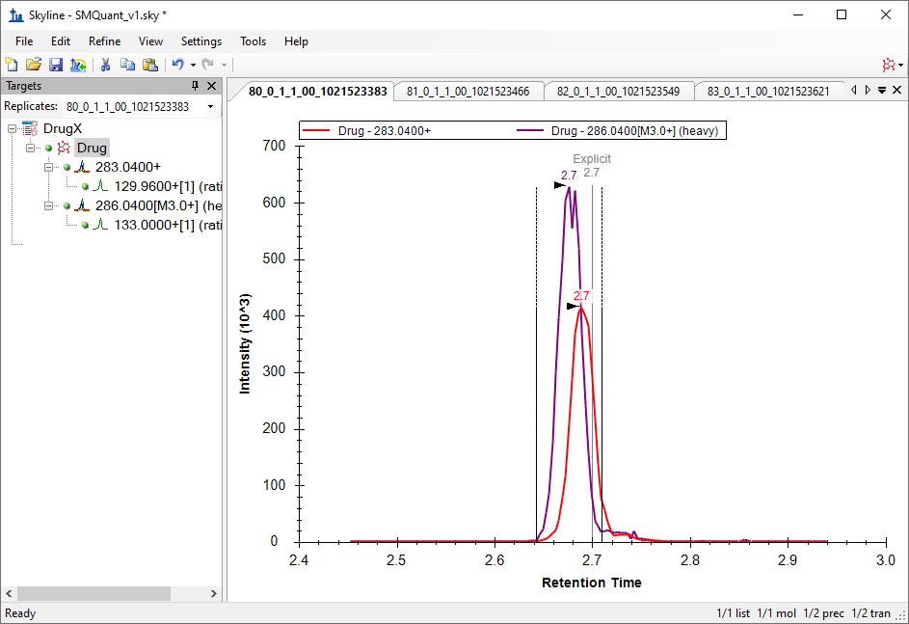

To take advantage of the Skyline summary graphs for viewing individual targets, do the following:

* On the **View** menu, choose **Peak Areas** and click **Replicate Comparison**.
* On the **View** menu, choose **Retention Times** and click **Replicate Comparison**.
* Click and drag these views to dock them above the chromatogram graphs.
* In the **Targets** view select the first target “Drug”.

The Skyline window should now look like this:

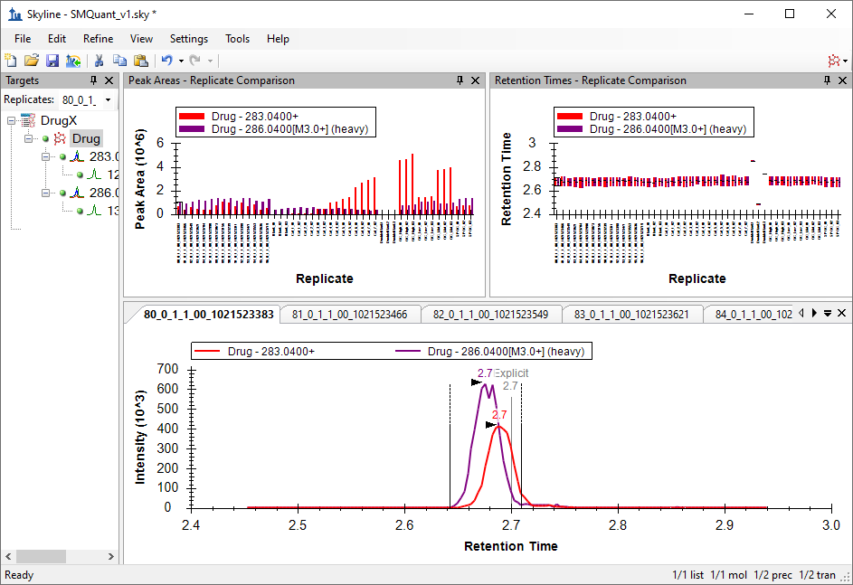

# Checking Peak Integration

Looking at the **Retention Times – Replicate Comparison** window, you can see by the outliers in replicates with “DoubleBlank” in the name that Skyline has not chosen peaks at retention times consistent with the other replicates.

To have a closer look at the chromatograms for one of these runs do the following:

* In the **Retention Times – Replicate Comparison** view, click the bars for the first outlier DoubleBlank1.

You would not actually expect Skyline to find a good peak for either the light or heavy form of the drug in this replicate, because the term “DoubleBlank” implies that neither is present in the sample. The chromatogram graph now shows you what peaks Skyline had to choose from:

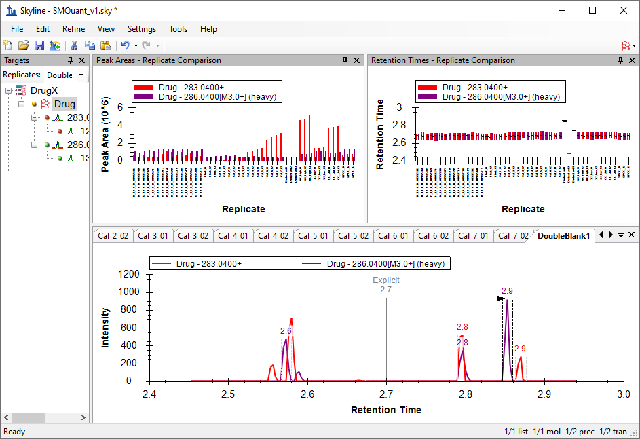

* Click on the bars for the other two outliers in the **Retention Times – Replicate Comparison** view.

This should reveal that DoubleBlank2 and DoubleBlank3 also lack any clear peak around the time 2.7 annotated with “Explicit”, meaning the method explicitly specified 2.7 minutes as the expected elution time. As these are also double blanks, you should not expect any actual peaks in these replicates, so you will next manually adjust the integration for each of the double blank replicates to center on the low signal area at 2.7 minutes.

# Adjusting Peak Integration

To adjust peak integration, follow these steps:

* In the **Targets** view **Replicates** dropdown list, select the “DoubleBlank1” replicate.
* Position the mouse cursor below the **Retention Time** axis (the cursor will change east-west arrows:).
* Click below the **Retention Time** axis at about 2.65 minutes and drag to about 2.75 minutes.

The peak boundaries will change to these new values, and the original range will be marked by a shaded area, as shown below:

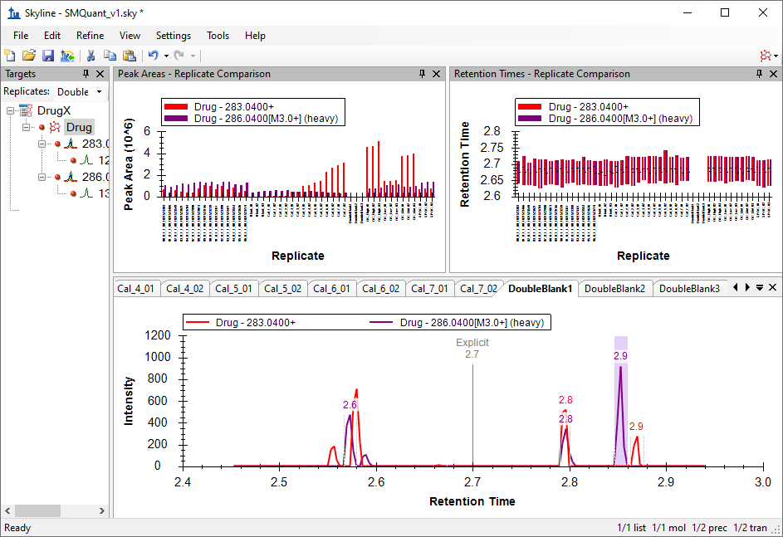

Repeat the steps above for the other two “DoubleBlank” replicates.

# Preparing for Quantitation

Next to set up quantitative calibration, perform the following steps:

* On the **Settings** menu, click **Molecule Settings**.
* Click the **Quantification** tab.
* In the **Regression fit** dropdown list choose “Linear”.
* In the **Normalization method** dropdown list, choose “Ratio to Heavy”.
* In the **Regression weighting** dropdown list, choose “1 / (x*x)”
* You may leave the **MS level** dropdown list showing “All”.
* In the **Units** field, enter “uM”.

The **Molecule Settings** form should look like this:

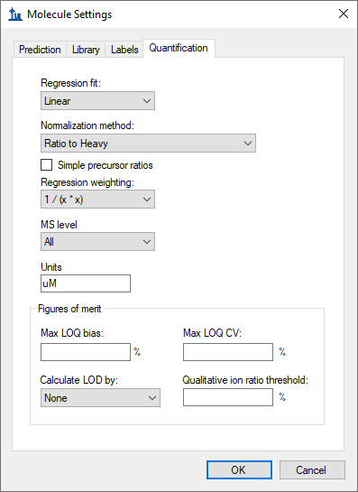

This experiment uses a linear regression fit, normalizing to the heavy labeled drug. Skyline offers options for weighting across the curve as a function of x: None, 1/x, and 1/(x*x). This tutorial uses a regression weighting of “1 / (x*x)” which increases the weight of the lower concentration calibration samples. The **Units** field is for display purposes, and can be set to any value that makes sense for your experiment. The concentrations in this experiment were calibrated in micromolar, so the **Units** field is set to “uM”.

* Click the **OK** button.

The calibration curve is not quite ready to view yet. First you must declare the sample types and calibrated concentrations of various replicates.

# Declaring Sample Types for Calibration Curve Display

The **Document Grid** will be used to examine and add information about the various replicates. The **Document Grid** is a highly useful tool in Skyline, providing spreadsheet-like views of many document details, many of which can be edited right in the grid. In this case, you need to supply details for the various replicates as follows:

* On the **View** menu, click **Document Grid**.
* Click **Reports** in the upper left corner of the grid, and choose **Replicates**.

The **Document Grid** should look like this:

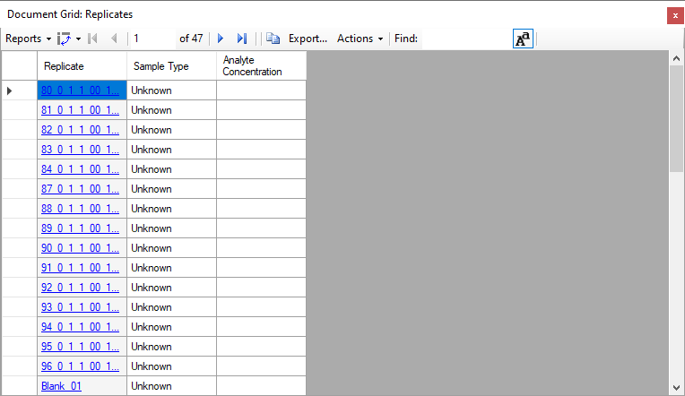

* Expand the **Document Grid** if needed so that you can see all the replicates at once if you screen is large enough.
* Sort the list alphabetically, by clicking on the “Replicate” column header and choosing “Sort Ascending”.

By default all of the replicates have been given the **Sample Type** value of “Unknown”. This is the desired type for all of the replicates with names beginning with a number. Beyond these, you should do the following:

* Click on the **Sample Type** field for “Blank_01”.
* Change the value from “Unknown” to “Blank”.
* Now shift+click on the **Sample Type** for “Blank_03” to select all three blank replicates at once.
* Right-click the selection and click **Fill Down**.

Everything in the multiple selection now has the same value as the first item in the selection.

Repeat as needed (or, skip ahead to the table below):

* Set the “Cal_” replicates to the “Standard” **Sample Type**
* Set the “DoubleBlank_” replicates to the “Double Blank” **Sample Type**
* Set the “QC_” replicates to the **“**Quality Control” **Sample Type**

Recall that the “SPCQC_” replicates are quality control in a different sense (a pooling of all study samples), so those are left as “Unknown”.

Analyte concentrations can be entered by hand, but it is much easier to copy and paste them into the grid.

* Navigate to the “SmallMoleculeQuant” folder and open the “Concentrations.xlsx” file in Excel or any text editor. It should look like this:

|  |  |  |
| --- | --- | --- |
| Blank_01 | Blank |  |
| Blank_02 | Blank |  |
| Blank_03 | Blank |  |
| Cal_1_01 | Standard | 10 |
| Cal_1_02 | Standard | 10 |
| Cal_2_01 | Standard | 20 |
| Cal_2_02 | Standard | 20 |
| Cal_3_01 | Standard | 100 |
| Cal_3_02 | Standard | 100 |
| Cal_4_01 | Standard | 200 |
| Cal_4_02 | Standard | 200 |
| Cal_5_01 | Standard | 400 |
| Cal_5_02 | Standard | 400 |
| Cal_6_01 | Standard | 600 |
| Cal_6_02 | Standard | 600 |
| Cal_7_01 | Standard | 800 |
| Cal_7_02 | Standard | 800 |
| DoubleBlank1 | Double Blank |  |
| DoubleBlank2 | Double Blank |  |
| DoubleBlank3 | Double Blank |  |
| QC_High_01 | Quality Control | 589 |
| QC_High_02 | Quality Control | 589 |
| QC_High_03 | Quality Control | 589 |
| QC_Low_01 | Quality Control | 121 |
| QC_Low_02 | Quality Control | 121 |
| QC_Low_03 | Quality Control | 121 |
| QC_Mid_01 | Quality Control | 346 |
| QC_Mid_02 | Quality Control | 346 |
| QC_Mid_03 | Quality Control | 346 |
| SPQC_01 | Unknown |  |
| SPQC_02 | Unknown |  |
| SPQC_03 | Unknown |  |

* Make sure the column order matches the **Document Grid**
* In Excel, **Select All** (Ctrl-A), then **Copy** (Ctrl-C).
* In the **Document Grid,** click on the “Blank_01” cell and click **Paste** (Ctrl-V).

The **Document Grid** should look like this when done: 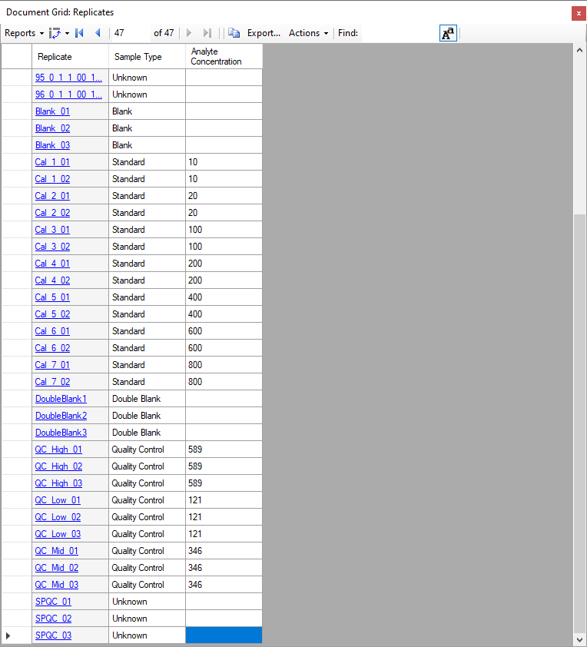

# Inspecting the Calibration Curve

It is time to examine the calibration curve graph.

* Close the **Document Grid**.
* On the **View** menu, click **Calibration Curve**.

The **Calibration Curve** form should appear looking like this:

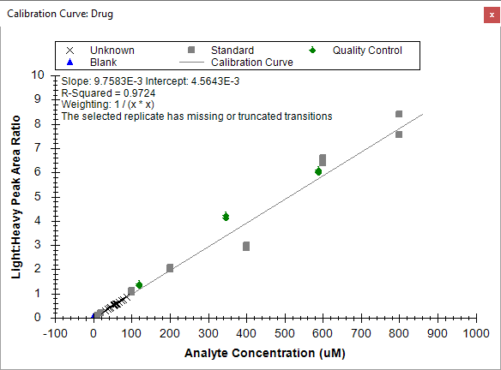

The note about the selected replicate missing transitions is expected, when the currently selected replicate is a double blank.

Looking at the graph, you can see the “Unknowns” appear as X marks mostly between the Light:Heavy ratios of 1.0 and 0.

You may also note that some of the calibration samples are not as close to the regression line as might have been hoped. By using the **Document Grid** to get a qualitative sense of just how far off they are, you can exclude any samples that are not suitable. To do that, follow these steps:

* On the **View** menu, click **Document Grid**.
* Click on **Reports** in the upper left corner of the grid, and then click **Replicates**.
* Click again on **Reports** in the upper left corner of the grid, and then click **Customize Report**.
* Click on the search button  and enter “accuracy” into the **Find what** field.
* Click the **Find Next** button.
* Click the **Close** button on the **Find Column** form.
* In the **Customize Report** form, **Accuracy** should be highlighted under the **Quantification** subcategory.
* Check the **Accuracy** checkbox**.**
* In **Molecule Results** (which is just above **Quantification**), check **Exclude From Calibration**.
* In the **Report Name** field at the top of the **Customize Report** form, enter “Replicates_custom_quant”.
* Click the **OK** button.

The **Document Grid** should now look like this: 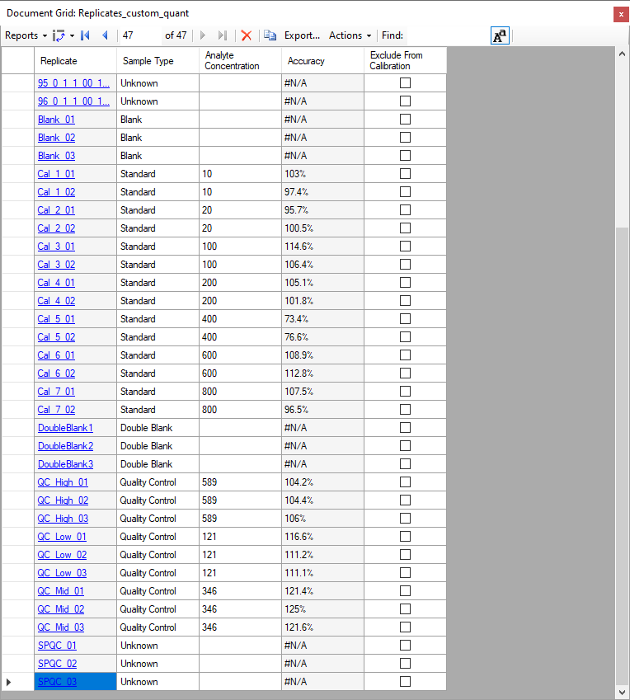

The FDA Guidance on which this assay was based states that calibration points should have bias < 15% (accuracy between 85% and 115%) between the known concentration and the back-calculated concentration from the calibration curve. **Accuracy** column shows that “Cal_5” does not meet that test. These replicates can be removed from consideration using the checkbox in the **Exclude from Calibration** column in the **Document Grid**, or by right-clicking on the outlier in the **Calibration Curve** form and clicking **Exclude from Calibration.** Follow these steps to remove the Cal_5 replicates from the calibration regression:

* In the **Document Grid**, click on the checkbox in the **Exclude from Calibration** column for the “Cal5_01” replicate, then press the down arrow key.
* Repeat for “Cal5_02”.

The Calibration Curve should now look like the image below. Note that the R-squared value improves from 0.97 to >0.99 by excluding the outlier “Cal_5” values.



Next you should import the rest of the unknowns using the following steps:

* On the **File** menu, choose **Import** and click **Results**.
* In the **Import Results** form, choose **Import single-injection replicates in files**.
* In the **Files to import simultaneously** dropdown list at the bottom of the form, click **Many** which will provide the best import performance.
* Click the **OK** button.
* The **Import Results Files** form appears and displays a collection of raw data files. Select the unknown runs with file names that begin with numbers lower than 80, i.e. up to the prefix “79_”. (Note: Skyline should ignore any overlap with the files you have already imported.)
* Click the **OK** button.

A convenient way to view quantification data is to once again use the **Document Grid**, this time with the **Molecule Ratio Results** view.

* In the **View** menu, click **Document Grid**.
* In the **Reports** dropdown list, click **Molecule Ratio Results**.
* Click the **Replicate** column header and select **Sort Ascending**.

The **Document Grid** should look like this:

After removal of the two “Cal_5” datapoints, further exploration of the data reveals that one of the “Cal_7” points has accuracy <85% and should likely be removed. This will have little effect on the measurement of the samples, since there are no samples above the level of “Cal_6”, and only four samples have levels between “Cal 4” and “Cal 6”.

To enable easier visualization of the dynamic range of the samples along the calibration curve:

* Right-Click in the calibration curve window and click **Log X Axis**.
* Right-Click in the calibration curve window and click **Log Y Axis**.
* Click and drag a rectangle around the lowest and the highest Standard points (gray rectangles) to zoom into the range between them.

The calibration curve should look like this:

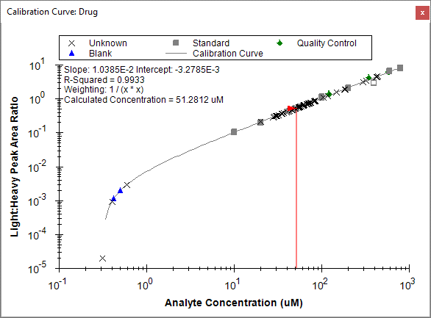

This presents a view which allows you to see at a glance that the samples mostly fall between “Cal_2” (20 uM) and “Cal_3” (100 uM), and well within the linear calibration range of the assay. The Quality Control samples (known unknowns, green diamonds in the graph) all have accuracy measured between 85 and 115%, which meets the FDA Guidance criteria.

From here, the next steps would be to export the data for external statistical processing, or to establish biological grouping within this document and to utilize some of the statistical analysis tools or plugins within Skyline. These options are covered in other tutorials.

# Conclusion

In this tutorial, you have learned how to create a Skyline document that targets small molecules specified as precursor ion chemical formulas and adducts, and product ion m/z values. You imported a multi-replicate data set collected using LC-MS/MS on a triple quadrupole, and saw how many existing Skyline features created initially for targeted proteomics use can now be applied to small molecule data.